COSC 310

Software Engineering

Assignment 4

Drew Ingram

16680076

2)

My GitHub account:

<https://github.com/Bobmcbobson>

My GitHub repository:

<https://github.com/Bobmcbobson/COSC310_project>

3,4) Partnered up with Justin Lee. His submission contains the answers for questions 3 and 4.

5)

Functionality, Sony:



The bottom bar is an ad obscuring nearly half of the screen. The rest of the page keeps scrolling sideways, changing what is displayed. This makes it difficult to see what is going on on the home page.

Navigation, SH marketing:



Some of the circles here are links leading to different parts of the site. The rest float around and bump into each other when they are hit by the cursor. It is not clear which of these are links, and the only way to tell which circle links to what page is by hovering over each one.

The top two examples were found on http://www.webpagesthatsuck.com/

But no critiques from the site were used in answering this question.

Presentation, Clker.com:



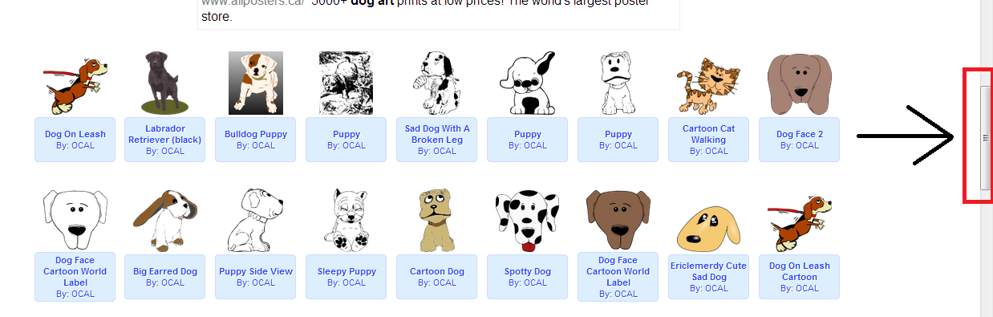

When a search is done for clipart, the results do not appear on the screen. Instead, they appear lower on the page, so the user does not see them until he scrolls down. It is not even clear that the search has returned any results at all.